NOTE: Photos should be taken at all applicable steps to obtain objective evidence for Customer and NanoRacks satisfaction. Utilize the Comment section at the end of this document as required to record actions taken, forward work, or nonconformances noted.

CAUTION: Maintain strict compliance with safe ESD processes as required.

Pre-Vibe Integration:

- Visually inspect the shipping container of the NRCSD qualification unit and take photos for objective evidence. Record any observations.
Recorded Observations:

- Remove the NRCSD from any packing materials and place on the integration workbench.
Recorded Observations:

- Record NRCSD serial number.
Recorded Observations:

NRCSD S/N:

- Perform a visual inspection and note any abnormalities or damage. Note, the qualification unit has experienced many vibration tests and so markings on the external surfaces are to be expected.
Recorded Observations:

- Verify cleanliness of NRCSD qualification unit external surfaces. If necessary, clean NRCSD unit with isopropyl alcohol.
Recorded Observations:

- Remove the front and rear NRCSD access panels on the +Y face (ref Figure 2) using a 5/64” hex head wrench. Set aside access panel screws in separate containers for the front and back access panel. Record any observations.
Note, the qualification unit has blue tape over 4-5 access panel screw holes. Do not remove this tape or install any access panel screws through these holes. They are not required for fit-check or vibration test.
Recorded Observations:

- Verify that NRCSD pusher plate assembly is in the restrained configuration. Ensure that the retainer thumb screw is fully engaged before proceeding (turn clockwise by hand until screw bottoms out).
Recorded Observations:

- Remove the baseplate retainer screws (QTY: 8) using a 5/64” hex head wrench. Set aside screws for re-use.
Recorded Observations:

- Remove the baseplate / pusher plate assembly by pulling on the baseplate retainer bolt.
Recorded Observations:

- Inspect the inside of the NRCSD through the access ports and baseplate opening and verify cleanliness. If necessary, clean with isopropyl alcohol.
Recorded Observations:

- Verify that the NRCSD thumb screw on the doors is in place and secure. Note, the running torque on this fastener is high and so a 5/32” hex wrench should be used to verify screw is completely engaged. Installation torque is 40 in-lbs over running.
Recorded Observations:

- Obtain CubeSat for integration. Record CubeSat name, part number, and serial number.
Recorded Observations:
CubeSat Name
P/N:
S/N:

- Record locations of any separation switches or deployment springs. Make indications of switch locations on figure below (using NRCSD coordinate system).
Recorded Observations:

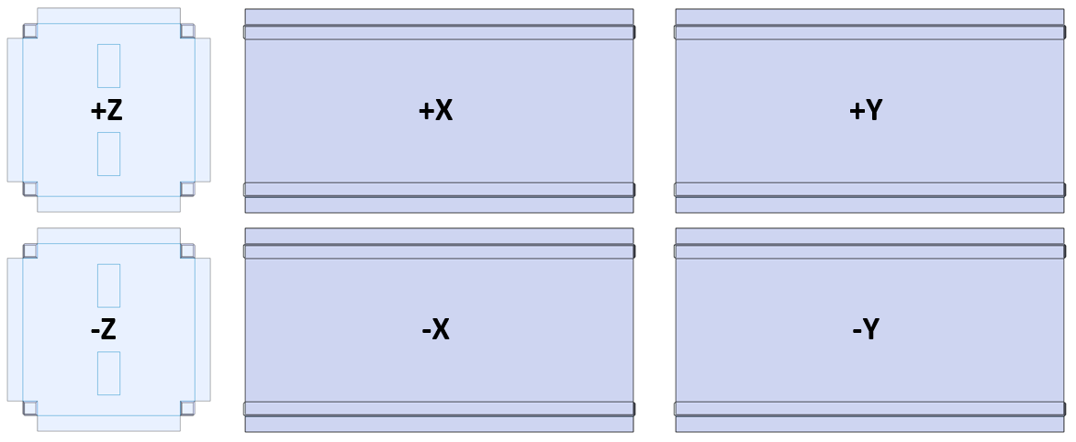

- Take photos of all six external faces of CubeSat.
Recorded Observations:

- Record the final mass of the CubeSat.
Recorded Observations:

CubeSat Mass (kg)

- Verify the RBF pins can remain in place during integration into NRCSD. If RBF pins not accessible via NRCSD access ports, determine alternative method of removing RBF during integration.
Recorded Observations:

- Insert CubeSat from the back of the deployer (opposite side of the doors). Make sure to load the CubeSat in the identical configuration that is planned for flight (consult NanoRacks if unsure). Take pictures of this configuration. Record any observations during the fit-check in the below steps.
Note, the doors on the qualification unit cannot be opened. This unit is strictly to be used for fit-checks and vibration tests to NanoRacks approved levels.
Recorded Observations:

- Verify that CubeSat slides freely along rails. Slide the CubeSat all the way to the front of the deployer and then back again. Record any observations about fit.
Recorded Observations:

- Manipulate the CubeSat to extreme positions within the rails and verify that any deployment switches along the rails cannot disengage (listen for mechanical ‘click’).
Recorded Observations:

- Verify that there is acceptable envelope clearance between the deployer side walls and the CubeSat side panels. Take pictures of all 4 sides.
Recorded Observations:

- Obtain any required flight spacers or mass models for the test. Record spacer length and mass.
Recorded Observations:
Spacer / Mass Model Length:
Mass (kg):
Additional Spacers Info (Quantity, Length, Mass):
Total Mass of all Mass Models / Spacers (kg):
Note, if testing with a mass model, additional ‘spacers’ may be required to increase the total length of the system. Nominal mass model length is ~367mm. Spacers to be provided as needed (each with a length of ~10-15mm). Total system length (including CubeSat) must be between 717 and 745mm.

- Verify cleanliness of spacer / mass models. If necessary, clean with isopropyl alcohol.
Recorded Observations:

- Insert mass model / spacer unit into the NRCSD from the back (opposite side of the doors). Slide the mass models until coincident with CubeSat rail ends inside the NRCSD. If spacer extensions are required to increase the total system length, those should be installed at the back of the deployer (to interface with deployer pusher plate, not the CubeSat). Slide the mass models until coincident with CubeSat rail ends inside the NRCSD.
Recorded Observations:

- Obtain base plate / pusher plate assembly and ensure that the retainer thumb screw is fully engaged. Reinstall the base plate assembly with the eight (8) base plate retainer screws and torque to specification 6 in-lbs using a 5/64” hex head wrench. Note, there are six (6) countersunk / flat head screws and two (2) button head screws. Install button head screws into holes with no recess.
Recorded Observations:

- Remove pusher plate retainer bolt by rotating the thumb screw counter-clockwise until it is no longer engaged with the pusher plate.
Recorded Observations:

- Install NRCSD jack screw into the center of the baseplate (5/16”-24 set screw) using a 5/32” hex bit. Record the length of jack screw used (maximum 2”). Torque jack screw to specification 2 in-lbs.
Note, a variety of jack screw lengths have been provided to accommodate varying system lengths. Ensure that enough jack screw threads are exposed beyond the baseplate to engage completely with the jam nut (see next step).
Recorded Observations:
Jack Screw Length
Torqued to 2 in-lbs?

- Install NRCSD Jam Nut (P/N: MS51972-2D) onto jack screw. During installation, first hand tighten the jam nut while using a 5/32” hex key to hold the jack screw in position. While using the hex key to secure the jack screw, torque the jam nut to specification 30 in-lbs with a 1/2” wrench.
Recorded Observations:

- Inspect the integrated system and ensure that the CubeSats cannot move within the NRCSD in the direction of pre-load (X-axis). Pick NRCSD up and bias in each direction to verify CubeSats and mass models cannot move.
Recorded Observations:

- Take several pictures of the integrated assembly through the access panels of the NRCSD. Verify that RBF has been removed and document final position of CubeSats / spacers inside NRCSD below.
Recorded Observations:
RBF Removed?
CubeSat in Front of the Deployer (P/N, S/N)
CubeSat in Back of the Deployer
(P/N, S/N)

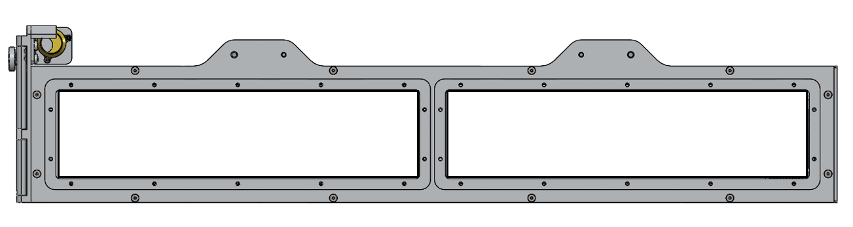

- Install front and rear NRCSD access panels with 5/64” hex wrench. Torque to specification 6-in-lbs.
Recorded Observations:

- End of integration procedure. If shipping the NRCSD to vibration facility, pack for shipment and take final closeout pictures of NRCSD in packed configuration.
Recorded Observations:

Vibration Test:

Note, random vibration test to be performed to levels outlined in the NanoRacks Vibration Test Guidance Document (NR-SRD-085, Rev0.4). Test must be conducted in all three (3) axes for a minimum duration of 60 seconds. Perform low-level sine sweep surveys before and after the random vibration tests as deemed necessary (not required by NanoRacks).

- Remove the NRCSD from transport case once at vibration test facilities and record any observations.
Recorded Observations:

- Secure an NRCSD compatible interface plate to the vibration table (must adhere to bolt-hole pattern of NRCSD Qual-Unit bottom plate). Note, this plate must be fabricated in advance of test or may be provided by NanoRacks.
Recorded Observations:

- Secure the integrated NRCSD Qual-Unit assembly to the vibration table fixture with the ¼”-28 socket head captive screws. Torque to specification 55 in-lbs.
Recorded Observations:

- Perform random vibration test for all 3 axes. Note, NRCSD and interface plate will need to be removed and reinstalled onto vibration table between each axis. Verify that the following test tolerances are met:
  - Frequency: +/-5%
  - Time: +10%/-0
  - Acceleration: +/-10%
  - ASD: +/-3 dB
Note, ASD tolerance sometimes difficult to achieve at frequencies above ~600Hz due to the extremely low energy input of the vibration profile. If necessary, test tolerances can be increased in the necessary frequency ranges in order to complete the test.
Recorded Observations:

- Once vibration testing is complete, pack NRCSD for return to satellite integration facilities. Take pictures of this configuration before transport.
Recorded Observations:

Post-Vibe Activities:

- Remove the NRCSD from transport case once at integration facilities and record any observations. Inspect NRCSD for any signs of damage or loose components.
Recorded Observations:

- Inspect NRCSD for any signs of damage or loose components.
Recorded Observations:

- Remove the front and rear NRCSD access panels using a 5/64” hex head wrench.
Recorded Observations:

- Install CubeSat remove before flight (RBF) pin/component if applicable.
Recorded Observations:

- Inspect the internal components of the NRCSD. Verify that the CubeSat is in a safe configuration for removal. Take several photos and record any observations.
Recorded Observations:

- Rotate jam nut located on the center of the NRCSD baseplate counterclockwise a quarter turn to remove torque using 1/2” wrench.
Recorded Observations:

- Remove jackscrew located on the center of the NRCSD baseplate using a 5/32” hex head wrench. Note, this removes the preload on the CubeSat inside the NRCSD so do not transport or move the hardware in this state.
Recorded Observations:

- Obtain pusher plate retainer thumb screw. Install thumb screw into the same hole at the center of the NRCSD baseplate that the jackscrew was removed from. Turn the thumb screw clockwise until the threads engage with the pusher plate inside the NRCSD. Rotate the thumb screw all the way until it can no longer be rotated. During this process, the engagement of the retainer bolt and the pusher plate of the NRCSD should be visible from the rear access port.
Recorded Observations:

- Verify that the pusher plate is fully engaged with the retainer bolt before proceeding.
Recorded Observations:

- Remove the baseplate retainer screws (QTY:8) using a 5/64” hex head wrench.
Recorded Observations:

- Remove the baseplate / pusher plate assembly by pulling on the baseplate retainer bolt.
Recorded Observations:

- Remove all mass models / spacers used for test. Inspect for any signs of damage and record observations.
Recorded Observations:

- Remove the CubeSat from the NRCSD and place on workbench on the CubeSat rail ends (or custom fixture). Record any observations of the CubeSat.
Recorded Observations:

- Inspect the inside of the NRCSD through the access ports and baseplate opening. Identify any FOD or loose components present inside the NRCSD and take multiple pictures.
Recorded Observations:

- Perform a complete post-vibration test inspection of the CubeSat. At a minimum verify the following.
  - All deployables stowed and retention mechanisms intact.
  - All external fasteners remain intact and torqued.
  - All frangible materials (such as solar arrays) are free of any cracks or damage.
  - Deployment switches are both electrically and mechanically functional (all switches have sufficient travel and perform their intended function)
Recorded Observations:

- Take photos of all six external faces of CubeSat and compare to pre-vibe photos.
Recorded Observations:

- End post-vibe inspection. Functional testing to be conducted as needed by customer. If any post-vibe testing breaks the configuration of the CubeSat in any way, this must first be approved by NanoRacks.
Recorded Observations:

- Return NRCSD to configuration in which it arrived. All access panel and baseplate retainer screws to be installed to specification 6 in-lbs. Ensure that the baseplate is installed with the pusher plate completely engaged with the retainer bolt.
Recorded Observations:

- Pack the NRCSD unit for return shipment to NanoRacks.
Recorded Observations:

Comments -- Notes / Actions / NCRs

Step Reference | Action Taken / Forward Work Required | Initiated | Closed

Figure 1: CubeSat Coordinate Reference
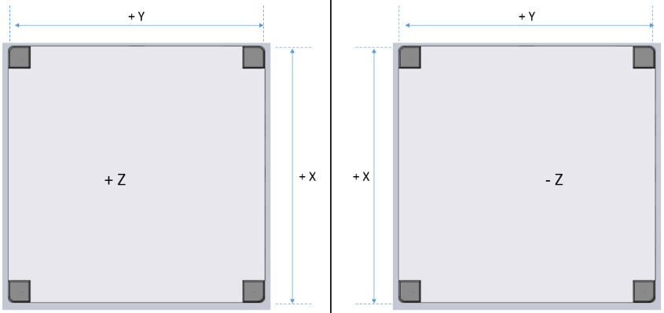
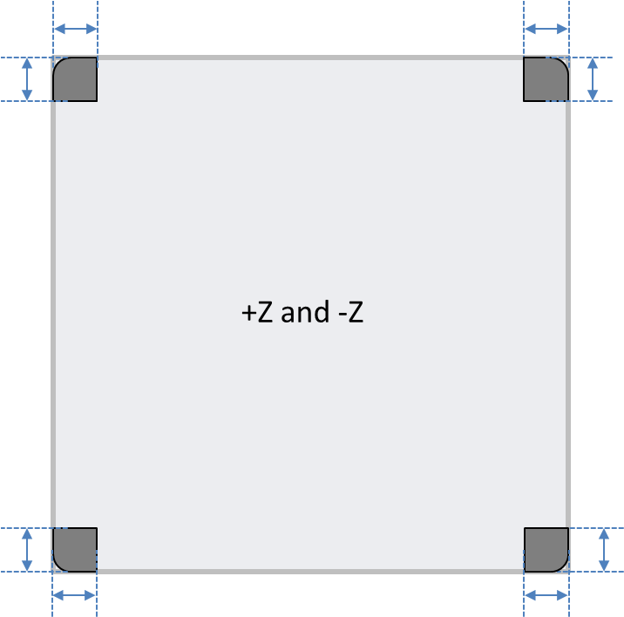 | 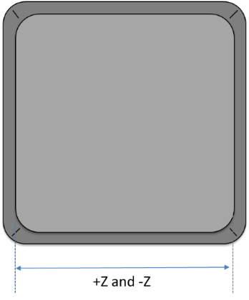
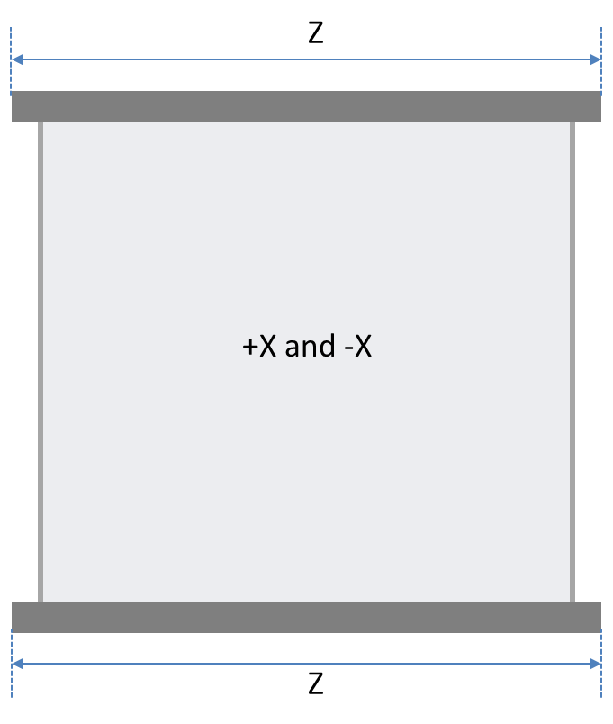

Figure 2: NRCSD Coordinate System

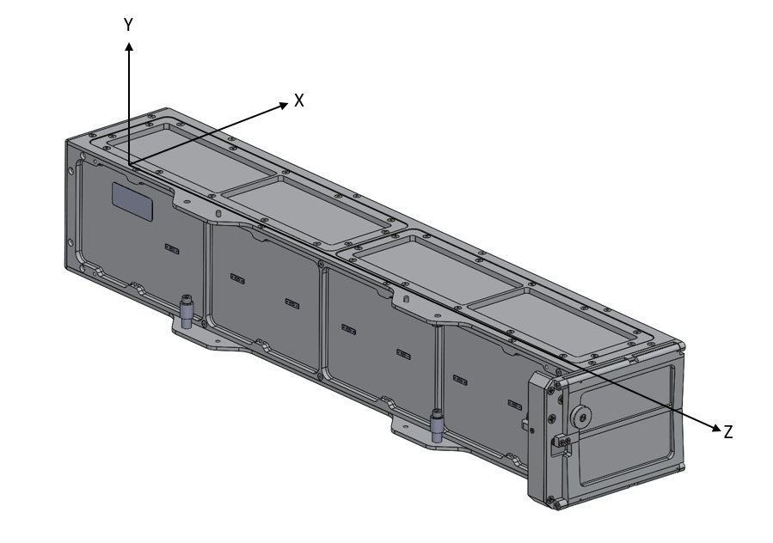

Notes: N/A = Not Available; N/R = Not Required; MIP = Mandatory Inspection Point; NCR = Nonconformance Report
Initiator: |  |  | Date |  |  | Date
Closure: |  |  |  | Total Pages:  (Att. Included)

